Lab 22

Configuring Group Policy preferences

This lab contains the following exercises and activities:

|  |  |
| --- | --- |
| Exercise 22.1 | Configuring Printer Settings |
| Exercise 22.2 | Configuring Network Drive Mappings |
| Exercise 22.3 | Configuring Power Options |
| Exercise 22.4 | Configuring IE Settings |
| Exercise 22.5 | Performing File, Folder, and Shortcut Deployment |
| Lab Challenge | Configuring Item-Level Targeting |

BEFORE YOU BEGIN

The lab environment consists of student workstations connected to a local area network, along with a server that functions as the domain controller for a domain called *contoso.com*. The computers required for this lab are listed in Table 22-1.

Table 22-1

Computers Required for Lab 22

|  |  |  |
| --- | --- | --- |
| Computer | Operating System | Computer Name |
| Server (VM 1) | Windows Server 2012 | RWDC01 |
| Server (VM 2) | Windows Server 2012 | Server01 |

In addition to the computers, you also require the software listed in Table 22-2 to complete Lab 22.

Table 22

Software Required for Lab 22

|  |  |
| --- | --- |
| Software | Location |
| Lab 22 student worksheet | Lab22worksheet.rtf (provided by instructor) |

Working with Lab Worksheets

Each lab in this manual requires that you answer questions, take screen shots, and perform other activities that you will document in a worksheet named for the lab, such as Lab22_worksheet.rtf. You will find these worksheets on the book companion site. It is recommended that you use a USB flash drive to store your worksheets, so you can submit them to your instructor for review. As you perform the exercises in each lab, open the appropriate worksheet file using WordPad, fill in the required information, and save the file to your flash drive.

After completing this lab, you will be able to:

* Configure Group Policy preferences including printers, network drive mappings, power options, Internet Explorer settings, and file and folder deployment
* Configure item-level targeting

Estimated lab time: 70 minutes

|  |  |
| --- | --- |
| Exercise 22.1 | Configuring Printer Settings |
| Overview | In this exercise, you configure a local printer using GPO preferences. |
| Completion time | 10 minutes |

**Mindset Question: During this lab, you continue working with group policies. What can you use to configure the Windows environment so that the settings are applied once, but can be reconfigured by the user in the future if so desired?**

**1.** Log in to Server01 as the **Contoso\Administrator** user account. The Server Manager console opens.

**2.** On Server01, right-click the Start button and open the Control Panel.

**3.** When the Control Panel opens, click View devices and printers, under Hardware.

**4.** Click Add a printer and click *The printer that I want isn’t listed*.

**5.** Click *Add a local printer or network printer with manual settings*. Click Next.

**6.** On the Choose a printer port page, use the existing port that is already set to LPT1. Click Next.

**7.** Under the manufacturer, click HP. Under Printers, click LaserJet 6L PS Class Driver. Click Next.

**8.** On the Type a printer name page, click Next.

**9.** On the Printer Sharing, click Next.

**10.** When the wizard is complete, click Finish.

**11.** Log in to RWDC01 as the **Contoso\Administrator** user account. The Server Manager console opens.

**12.** On Server Manager, open Group Policy Management.

**13.** Navigate to the Group Policy Objects container and click GPO5. If needed, click OK to close a message box that might appear. Then right-click GPO5 and click Edit. The Group Policy Management Editor opens.

**14.** Navigate to and click Computer Configuration\Preferences\Control Panel Settings\Printers as shown in Figure 22-1.

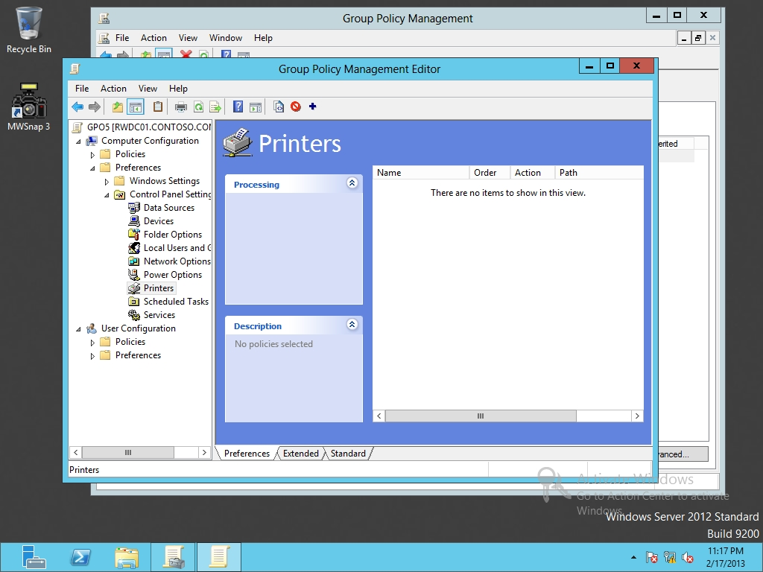

Figure 22-1

Configuring printers with preferences

**15.** Right-click the Printers node, click New, and select Local Printer. The New Local Printer Properties dialog box opens.

**16.** For Action, Update is already selected, as shown in Figure 22-2. For the name, type **Office Printer**. For port, click USB001. For the Printer Path, type **\\Server01\HP LaserJet 6L PS Class Driver**.

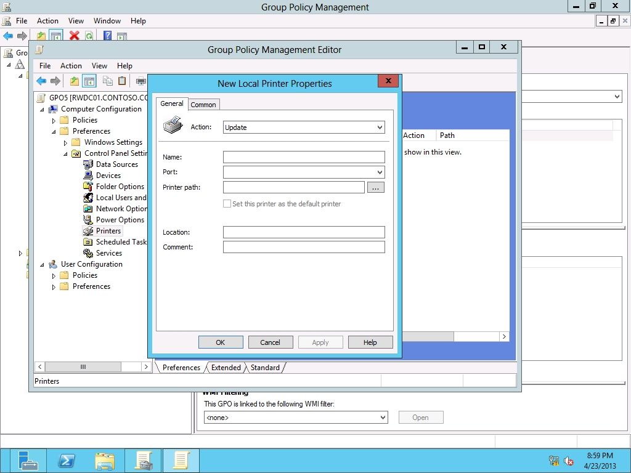

Figure 22-2

Configuring the printer settings

**17.** Click OK. The new preference item appears in the Printers pane.

**18.** Leave Group Policy Management Editor open for the next exercise.

|  |  |
| --- | --- |
| Question 1 | If you want to deploy a GPO based on where a user is located, where would you best assign the GPO? |

End of exercise. You can leave the windows open for the next exercise.

|  |  |  |
| --- | --- | --- |
| Exercise 22.2 | | Configuring Network Drive Mappings |
| Overview | In this exercise, you map a shared folder to the local I drive. | |
| Completion time | 5 minutes | |

**1.** On RWDC01, using the Group Policy Management Editor for GPO5, navigate to and click User Configuration\Preferences\Windows Settings\Drive Maps.

**2.** Right-click the Drive Maps node, click New, and select Mapped Drive. The New Drive Properties dialog box opens.

**3.** In the Location text box, type **\\Server01\Data**.

**4.** Under Drive Letter, select the I drive.

**5.** Under Hide/Show this drive, click Show this Drive.

**6.** Take a screen shot of the Group Policy Management Editor window by pressing Alt+Prt Scr and then paste it into your Lab22_worksheet file in the page provided by pressing Ctrl+V.

**7.** Click OK to close the New Drive Properties dialog box.

**8.** Leave the Group Policy Management Editor open for the next exercise.

End of exercise. You can leave the windows open for the next exercise.

|  |  |
| --- | --- |
| Exercise 22.3 | Configuring Power Options |
| Overview | In this exercise, you configure Power Options using GPO Preferences. |
| Completion time | 10 minutes |

**1.** On RWDC01, using the Group Policy Management Editor for GPO5, navigate to and click Computer Configuration\Preferences\Control Panel Settings\Power Options.

**2.** Right-click the Power Options node, click New, and select Power Plan (At least Windows 7). The New Power Scheme (At least Windows 7) Properties dialog box opens as shown in Figure 22-3.

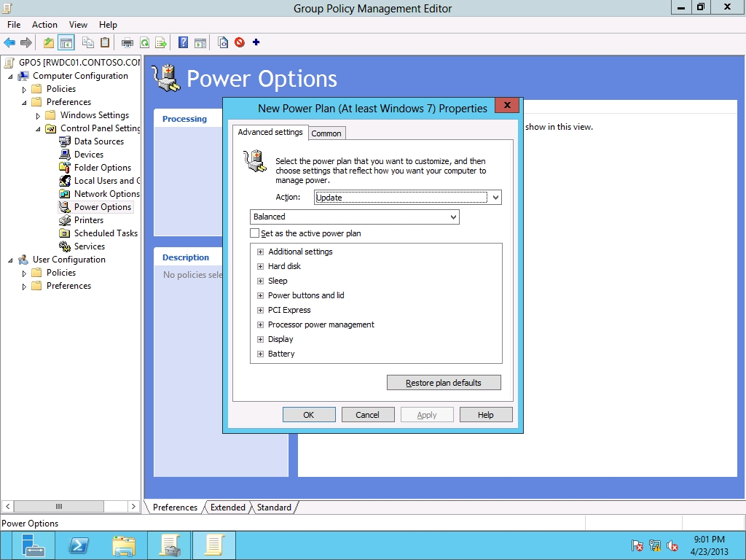

Figure 22-3

Creating a Power Plan

**3.** Expand Power buttons and lid, expand Lid close action and click Lid close action. Change the On battery and Plugged in setting of Sleep to Do nothing.

**4.** Expand Display and expand Turn off display after.

|  |  |
| --- | --- |
| Question 2 | How long does it take before the display is turned off when the system is plugged in? |

**5.** Click the Common tab.

**6.** Click Apply once and do not reapply.

**7.** Click OK to close the New Power Plan (At least Windows 7) Properties. The new preference item appears in the Power Options pane.

**8.** Leave the Group Policy Management Editor open for the next exercise.

End of exercise. You can leave the windows open for the next exercise.

|  |  |
| --- | --- |
| Exercise 22.4 | Configuring IE Settings |
| Overview | In this exercise, you configure IE (versions 8 through 10) with a predefined home page and pop-up blocker exceptions. |
| Completion time | 15 minutes |

**Mindset Question: You configure IE Settings and some of the options have a red dashed line under them. How can you enable all the settings that you have configured.**

**1.** On RWDC01, using the Group Policy Management Editor for GPO5, navigate to and click User Configuration\Preferences\Control Panel Settings\Internet Settings.

**2.** Right-click the Internet Settings node, click New, and select Internet Explorer 10. The New Internet Explorer 10 Properties dialog box opens as shown in Figure 22-4.

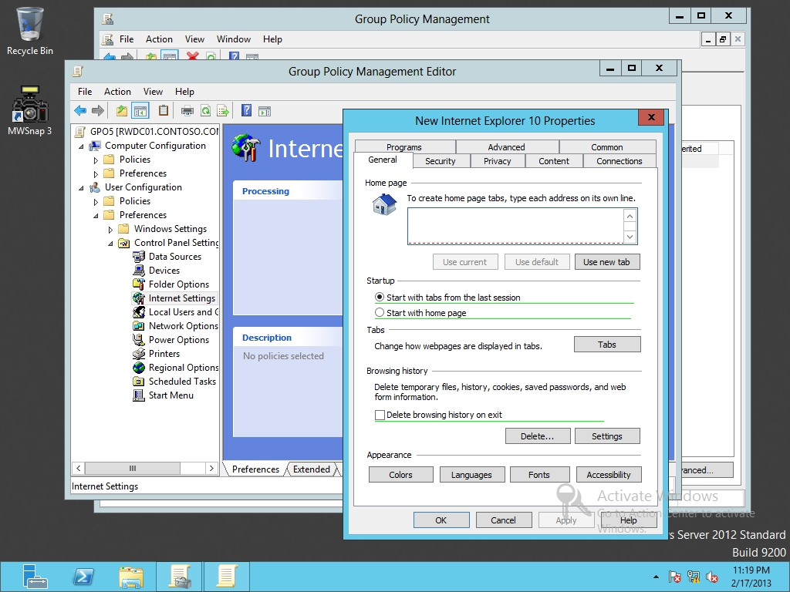

Figure 22-4

Configuring Internet Explorer 10 with preferences

**3.** Under the General tab, type **http://portal.contoso.com** in the Home page text box. Click Start with home page.

|  |  |
| --- | --- |
| Question 3 | What color is the home page set as? |

|  |  |
| --- | --- |
| Question 4 | What color is the Startup options set as? |

**4.** Click the Home page text box. Press the F5 key so that the box turns green.

|  |  |
| --- | --- |
| Question 5 | What key would you use to disable the current setting? |

**5.** Click the Privacy tab. Under the Pop-up Blocker section, click Settings.

**6.** When the Pop-up Blocker Settings dialog box opens, type **\*.contoso.com** in the Address of website to allow text box. Click Add. Click Close.

**7.** Click OK. The new preference item appears in the Internet Settings pane.

**8.** Right-click Internet Settings, click New, and click Internet Explorer 8 and 9.

**9.** Configure the setting similar to what you configured with the Internet Explorer 10 preference.

**10.** Take a screen shot of the Group Policy Management Editor window showing the Internet Settings by pressing Alt+Prt Scr and then paste it into your Lab22_worksheet file in the page provided by pressing Ctrl+V.

**11.** Leave Group Policy Management Editor open for the next exercise.

End of exercise. You can leave the windows open for the next exercise.

|  |  |
| --- | --- |
| Exercise 22.5 | Performing File, Folder, and Shortcut Deployment |
| Overview | During this exercise, you create a folder, copy a file to the folder, and create a shortcut to the folder using GPO Preferences. |
| Completion time | 15 minutes |

**Mindset Question: When performing a file deployment, what is the difference between Create and Update?**

**1.** On RWDC01, using the Group Policy Management Editor for GPO5, navigate to and click User Configuration\Preferences\Windows Settings\Files.

**2.** Right-click the Files node, click New, and select File. The New File Properties dialog box opens.

**3.** In the Source file(s) text box, and type **\\Server01\Data\Hello.bat**.

**4.** In the Destination File, click c:\hello.bat.

**5.** Take a screen shot of the New File Properties dialog box by pressing Alt+Prt Scr and then paste it into your Lab22_worksheet file in the page provided by pressing Ctrl+V.

**6.** Click OK to close the New File Properties dialog box.

**7.** Navigate to and click Computer Configuration\Preferences\Windows Settings\Folders.

**8.** Right-click the Folders node, click New, and select Folder. The New Folder Properties dialog box opens.

**9.** For the Action, select Create. In the Path text box, type **C:\Batch**.

**10.** Click OK to close the New Folder Properties dialog box.

**11.** Navigate to and click User Configuration\Preferences\Windows Settings\Shortcuts.

**12.** Right-click the Shortcuts node, click New, and select Shortcut. The New Shortcut Properties dialog box opens.

**13.** For the Action, select Create.

**14.** In the Name text box, type **Batch**.

**15.** Using the Location pull-down menu, select Desktop.

**16.** In the Target Path text box, type **C:\Batch**.

**17.** Click OK to close the New Shortcut Properties. The new preference item appears in the Shortcuts pane.

**18.** Close the Group Policy Management Editor.

Lab REview Questions

|  |  |
| --- | --- |
| **Completion time** | **5 minutes** |

**1.** In Exercise 22.1, what did you use to install and configure a printer?

**2.** In Exercise 22.2, what allows you to apply settings using a Group Policy once and then allow the user to change the settings in the future?

**3.** In Exercise 22.4, what key did you use to enable settings in IE settings?

**4.** In Exercise 22.5, you need to support IE 7, 8, 9 and 10. How many settings do you have to configure?

|  |  |
| --- | --- |
| Lab Challenge | Configuring Item-Level Targeting |
| Overview | To complete this challenge, you must explain how to use Item-Level Targeting. |
| Completion time | 10 minutes |

You have preferences. How would you modify the GPO5 so that it will affect only laptop computers?

End of lab. You can log off or start a different lab. If you want to restart this lab, you’ll need to click the End Lab button in order for the lab to be reset.